H.T No
Regulations:
A20

Sreenidhi Institute of Science and Technology
(An Autonomous Institution)
Code No:8AC41 Date: 29-Jan-2025 (FN)

B.Tech II-Year I- Semester External Examination, January-2025 (Supplementary)
BASIC ELECTRICAL ENGINEERING(CSE and IT))

Time: 3 Hours Max.Marks:70

Note: a) No additional answer sheets will be provided.
b) All sub-parts of a question must be answered at one place only, otherwise it will not be valued.
c) Missing data can be assumed suitably.
Bloom's Cognitive Levels of Learning (BCLL)

Remember | L1 | Apply | L3 | Evaluate | L5
Understand | L2 | Analyze | L4 | Create | L6

Part - A Max.Marks:20

Answer all QUESTIONS.

 |  | BCLL | CO(s) | Marks
1 | State ohm’s law and mention the limitations of it. | L1 | CO1 | [2M]
2 | Define form factor and peak factor | L2 | CO2 | [2M]
3 | Classify different types of losses present in DC Motor | L2 | CO3 | [2M]
4 | Analise what happen if SC test conducted at L.V side of the transformer. | L4 | CO4 | [2M]
5 | Draw the 3 Ø Star connection, and write relation between line and phase voltage in balanced system | L2 | CO5 | [2M]
6 | Define Indicating instruments | L2 | CO6 | [2M]
7 | State Maximum Power Transfer theorem | L1 | CO1 | [2M]
8 | Distinguish ideal and practical transformer | L2 | CO4 | [2M]
9 | Analyze the need of control torque in any measuring instruments. | L3 | CO6 | [2M]
10 | Write applications of Slipring Induction motor | L1 | CO5 | [2M]

Part – B Max.Marks:50
ANSWER ANY FIVE QUESTIONS. EACH QUESTION CARRIES 10 MARKS.

 |  |  | BCLL | CO(s) | Marks
11. | a) | Using Mesh analysis, find the mesh currents in the circuit  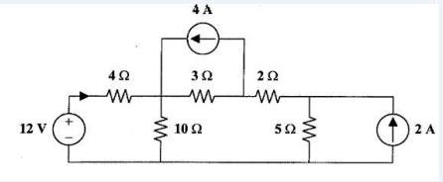 | L3 | CO1 | [5M]
 | b) | Derive the expressions for Delta -Star transformations | L2 | CO1 | [5M]
12. | a) | Find the average and RMS value for the following periodic current waveform with amplitude 6A  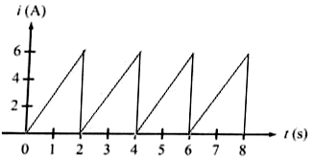 | L3 | CO2 | [5M]
 | b) | Consider a series RC circuit with R = 10Ω and C = 20 micro farads. The applied voltage is given by v(t) = 50 Sin(1000t). Calculate impedance of the circuit, current, voltage across  resistance and capacitor. | L3 | CO2 | [5M]
13. | a) | Explain the operation of DC Generator with neat diagram | L2 | CO3 | [5M]
 | b) | Derive EMF Equation of DC Generator | L2 | CO3 | [5M]
14. | a) | Draw and explain equivalent circuit of 1 - Ø transformer when reference to primary side. | L2 | CO4 | [5M]
 | b) | A 100 kVA, 2000 V/400 V, 50 Hz, 1- Ø transformer has an iron loss of 600 W and a full-load copper loss of 1600 W. Calculate its efficiency for a load of 60 kW at 0.8 power factor? | L3 | CO4 | [5M]
15. | a) | Differentiate between Squirrel cage and Slip ring Induction motors | L2 | CO5 | [5M]
 | b) | Derive voltage and current equations for a 3-ph balanced star connected load | L2 | CO5 | [5M]
16. | a) | Derive expression for extinction of range of MC type meters | L2 | CO6 | [5M]
 | b) | A meter of resistance 50 ohms has a full scale deflection of 4 mA.  Determine the value of shunt resistance required in order that full scale deflection should be (a) 15 mA (b) 20 A (c) 100 A | L3 | CO6 | [5M]
17. | a) | In the circuit given in fig. find the current (I)  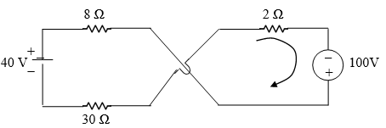 | L3 | CO1 | [4M]
 | b) | Define the following  - ‘J’ operator 2. Form factor 3. Instantaneous voltage | L1 | CO2 | [3M]
 | c) | Write the significance of back EMF in DC Motor | L1 | CO3 | [3M]
18. | a) | Compare core type and shell type transformer | L2 | CO4 | [4M]
 | b) | Define following  1.Slip 2. Slip speed 3. Synchronous Speed | L1 | CO5 | [3M]
 | c) | Discuss the need of extinction of range of an ammeter and voltmeter | L4 | CO6 | [3M]
-- 00 -- 00 –

